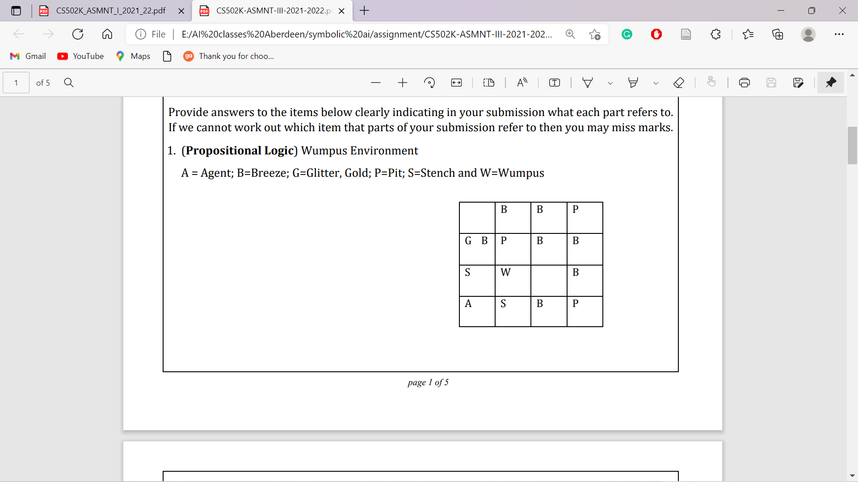

In case, if you have no idea about Wumpus world/environment refer this video [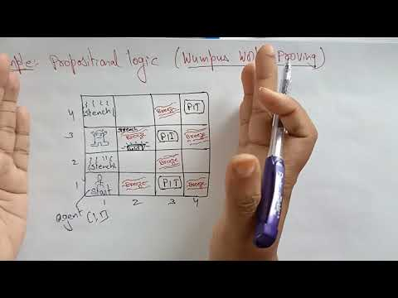](https://www.youtube.com/embed/fnwjsO9ky9o?feature=oembed)

In this problem, we have to make our agent intelligent enough to take his actions properly on its own based on the environment indications given.